Incoming Sophomore English II

Summer reading is an important part of a student’s learning experience in the STAMP & SPACE academies. Current research suggests that summer reading helps students maintain important literacy skills and provides all students with a shared experience on which to build upon when they return to school. Below are the summer reading directions for all incoming sophomore students. All students are responsible for their summer reading project.

REQUIRED SUMMER READING
The reading assignment will be due Tuesday, August 30, 2022
- Assignment - Read Animal Farm by George Orwell.
- As you read, complete the Reading Assessment Log Project.
- Submit your completed project to your English II teacher by Tuesday, August 30, 2022. (This project will be a major grade.) See Rubric. The assignment MUST be submitted via Google Classroom.

Should you have any questions or concerns, please contact your designated English II teacher from your campus.

Hanna ECHS | Adriana Tovar | adtovar@bisd.us
Lopez ECHS | Armando Sanchez | armandosanchez@bisd.us
Pace ECHS | Melissa Tully | matully@bisd.us
Porter ECHS | Belinda Hinojosa | bhinojosa2@bisd.us
Rivera ECHS | Teddy Cumberworth | tjcumberworth@bisd.us
Veterans ECHS | Jesus Vasquez | jesvasquez@bisd.us

Special Note: Student recently accepted in the STAMP & SPACE academies and or new to BISD, will be given this project at the beginning of the 2022-2023 school year and must successfully complete said project by Tuesday, September 27, 2022.

Assignment - Reading Assessment Log and One Pager Project
Your assessment log must be TYPED. – see provided template

- Student Name and Parent Verification: Please type your name and the following statement as the first section of your assessment. A parent signature MUST be included.
Student Name: ________________________________________________________
I verify that _______________________________has completed his/her summer reading.
Parent Signature: ____________________________________________
- Identify and properly punctuate the book’s title, author, copyright date, and number of pages in MLA format. Must include in text citation (parenthetical citation) Refer to following web page for MLA formatting questions: https://owl.purdue.edu/owl/purdue_owl.html

- Use the theme, ourselves and others to cite a memorable passage of no more than thirty words or three sentences from the book. Identify the page number, chapter, and copy word for word the short passage you feel is worth remembering and relates to the theme. Explain why you have selected this passage.

- Describe your first impression of one character or one event you find most interesting. Give at least THREE pieces of textual evidence that support this impression.

- Identify what causes a significant change in one character, and describe the results of that change. This change may be the consequence of a choice, a conflict of some kind that has to be resolved, the display of some outstanding trait like courage, or even the result of an action or event that occurs during the story. (What causes the significant change in the character? What are the results of the change?)

- Highlight the significance of the book for you, read all of the questions below and then write a response to ONE question.
- What discovery did you make as a result of reading the book?
- How has this book changed your thinking or feeling?
- How has this book challenged your opinions or views of life?

- Select FIVE literary devices and explain the effective use of this device. Be sure to include the type of device, page number, quote/sentence containing device, and the explanation of its effectiveness.

- Select FIVE vocabulary words from the text of the novel that you find challenging or interesting. Provide a dictionary definition for each word chosen, along with the page number and quote in which it appears. Then compose an original sentence using this word properly.

- The One Pager activity is used to assist you as you learn to analyze an author’s argument or purpose. It combines visual and textual elements. A one-pager is a written and graphic interpretation of what you have just read presented on a single sheet of paper. It may be literal (based strictly on the facts presented) or it may be a symbolic representation of the piece. The one-pager helps you visualize what you are reading.

What you’ll need to complete your One Pager:
- 1 poster larger than (8 ½ by 11)
- Markers and/or colored pencils
- A copy of the novel you have chosen

Design: What should your One Pager look like?
- Your name should be written on the back of the paper.
- Written work must be in ink (or marker/colored pencil).
- Use color.
- Ideas should be organized and presented clearly.
- Use your best penmanship. Your work needs to be legible.
- Organize your One Pager so that it makes sense.
- Creativity is a MUST! ☺

Content: What information should be included in your One Pager?
- The title of the novel must be included on your One Pager.
- Include the author’s full name.
- Copy three significant excerpts (quotations) from the text
- A response to each excerpt you selected explaining why you think it is important.
- At least 5 illustrations that represents the ideas discussed in the novel. (ie symbols, themes, motif, imagery, characters, etc

Assessment: How will your One Pager be graded?
- Your One Pager will be graded using the rubric on the back of this sheet.
- Your One Pager is an assessment grade and must be turned in on time.
- Your One Pager is due by Tuesday, August 30, 2022.

Guidelines:
- Use standard (8 ½ x 11) unlined paper (computer/printer paper)
- Fill the entire page
- Written work must be in ink or typed
- Use markers/colored pencils for illustrations
- Include all of the following – arrange on the page any way you choose
  - Title of Work, Author, Chapter or Section
  - Three or more excerpts (quotations) from the reading (passages you like or think are especially important)
  - A personal response to each passage you selected (an interpretation/explanation of its significance – answer “Why did I choose this excerpt?” and “Why is it significant to the literature?”
  - At least 1 graphic or symbol which relates to the passages selected (hand/computer illustration, magazine pictures, or clip art style)

Examples:

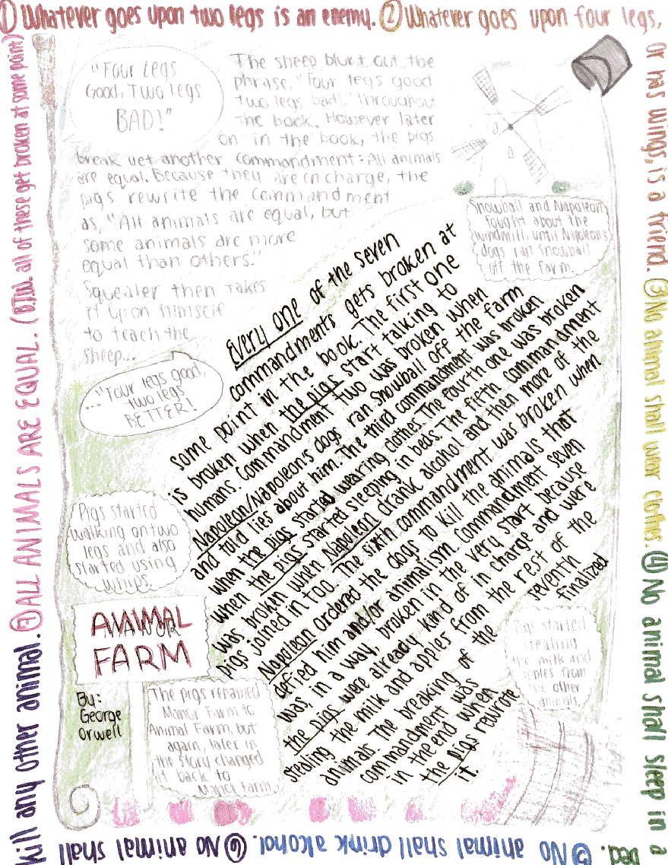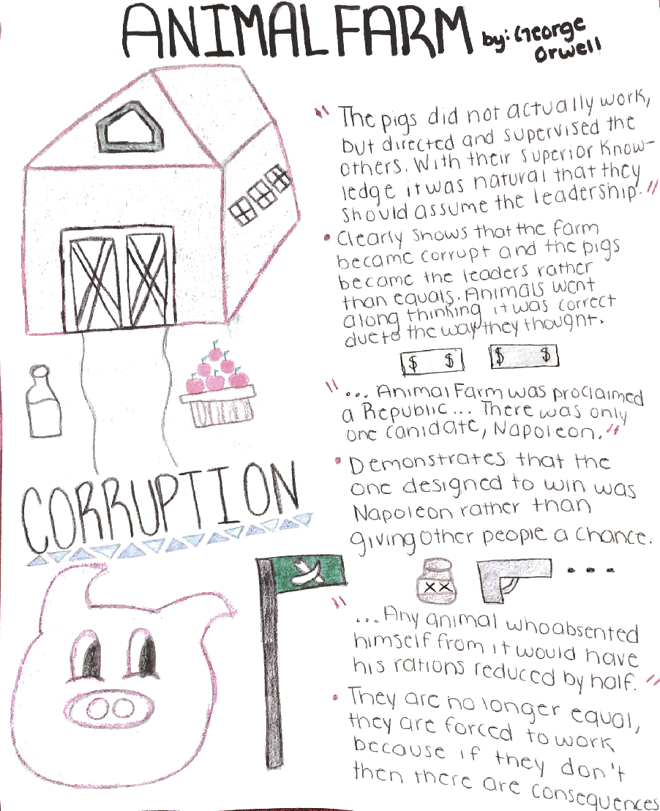

Grading Rubric: Reading Assessment Log & One-Pager
 | Developing  1 - 4 points |  | Sufficient  5 - 7 points |  |  | Above Average  8 - 9 points
MLA format | Some information is correctly documented. |  |  | Most information  is correctly documented. |  | All information is correctly documented.
Memorable Passage | Communicates information and ideas with some clarity. |  |  | Communicates information and ideas with considerable clarity. |  | Communicates information and ideas with a high degree of clarity.
Character Analysis | Uses critical thinking skills with moderate effectiveness. |  |  | Uses critical thinking skills with considerable effectiveness. |  | Uses critical thinking skills with a high degree of effectiveness.
Change in Character | Demonstrates minimal understanding of task. |  |  | Demonstrates adequate understanding of task. |  | Demonstrates a thorough understanding of task.
Book Significance | Communicates information and ideas with some clarity. |  |  | Communicates information and ideas with considerable clarity. |  | Communicates information and ideas with a high degree of clarity.
Literary Devices | Demonstrates somewhat developed integration and understanding of literary devices. |  |  | Demonstrates mostly developed integration and understanding of literary devices. |  | Demonstrates fully developed integration and understanding of literary devices.
Vocabulary | Completes some of the tasks effectively. |  |  | Completes most of the tasks effectively. |  | Completes all of the tasks effectively.
Analysis/ Personal Response | Analysis lacking or severely underdeveloped. Analysis does not indicate student has read or understood the book. |  |  | For each quotation, student includes 2-3 sentences of commentary/ analysis. |  | Analysis is thorough and sufficient. Demonstrated advanced thinking
Quotations | Required number of quotations not met or quotations & citations contain significant errors |  |  | Includes three accurate, correctly- cited (author, pg. #) quotations. |  | Quotations chosen are particularly powerful or connected in a particularly insightful way
Graphics& Required Elements | Graphic elements are clearly hastily drawn, in pencil, or incomplete.  Written elements are missing, sloppy, or in pencil. |  |  | Graphics are neat, clear, colorful, and fill the entire page.  All written elements are neat.  Title, author, and chapter are clearly written. |  | Graphic elements are particularly well chosen and executed.  Required elements are incorporated seamlessly into the artwork.
Parent signature – 3 points
Creativity – 7 points
________/100 total points

